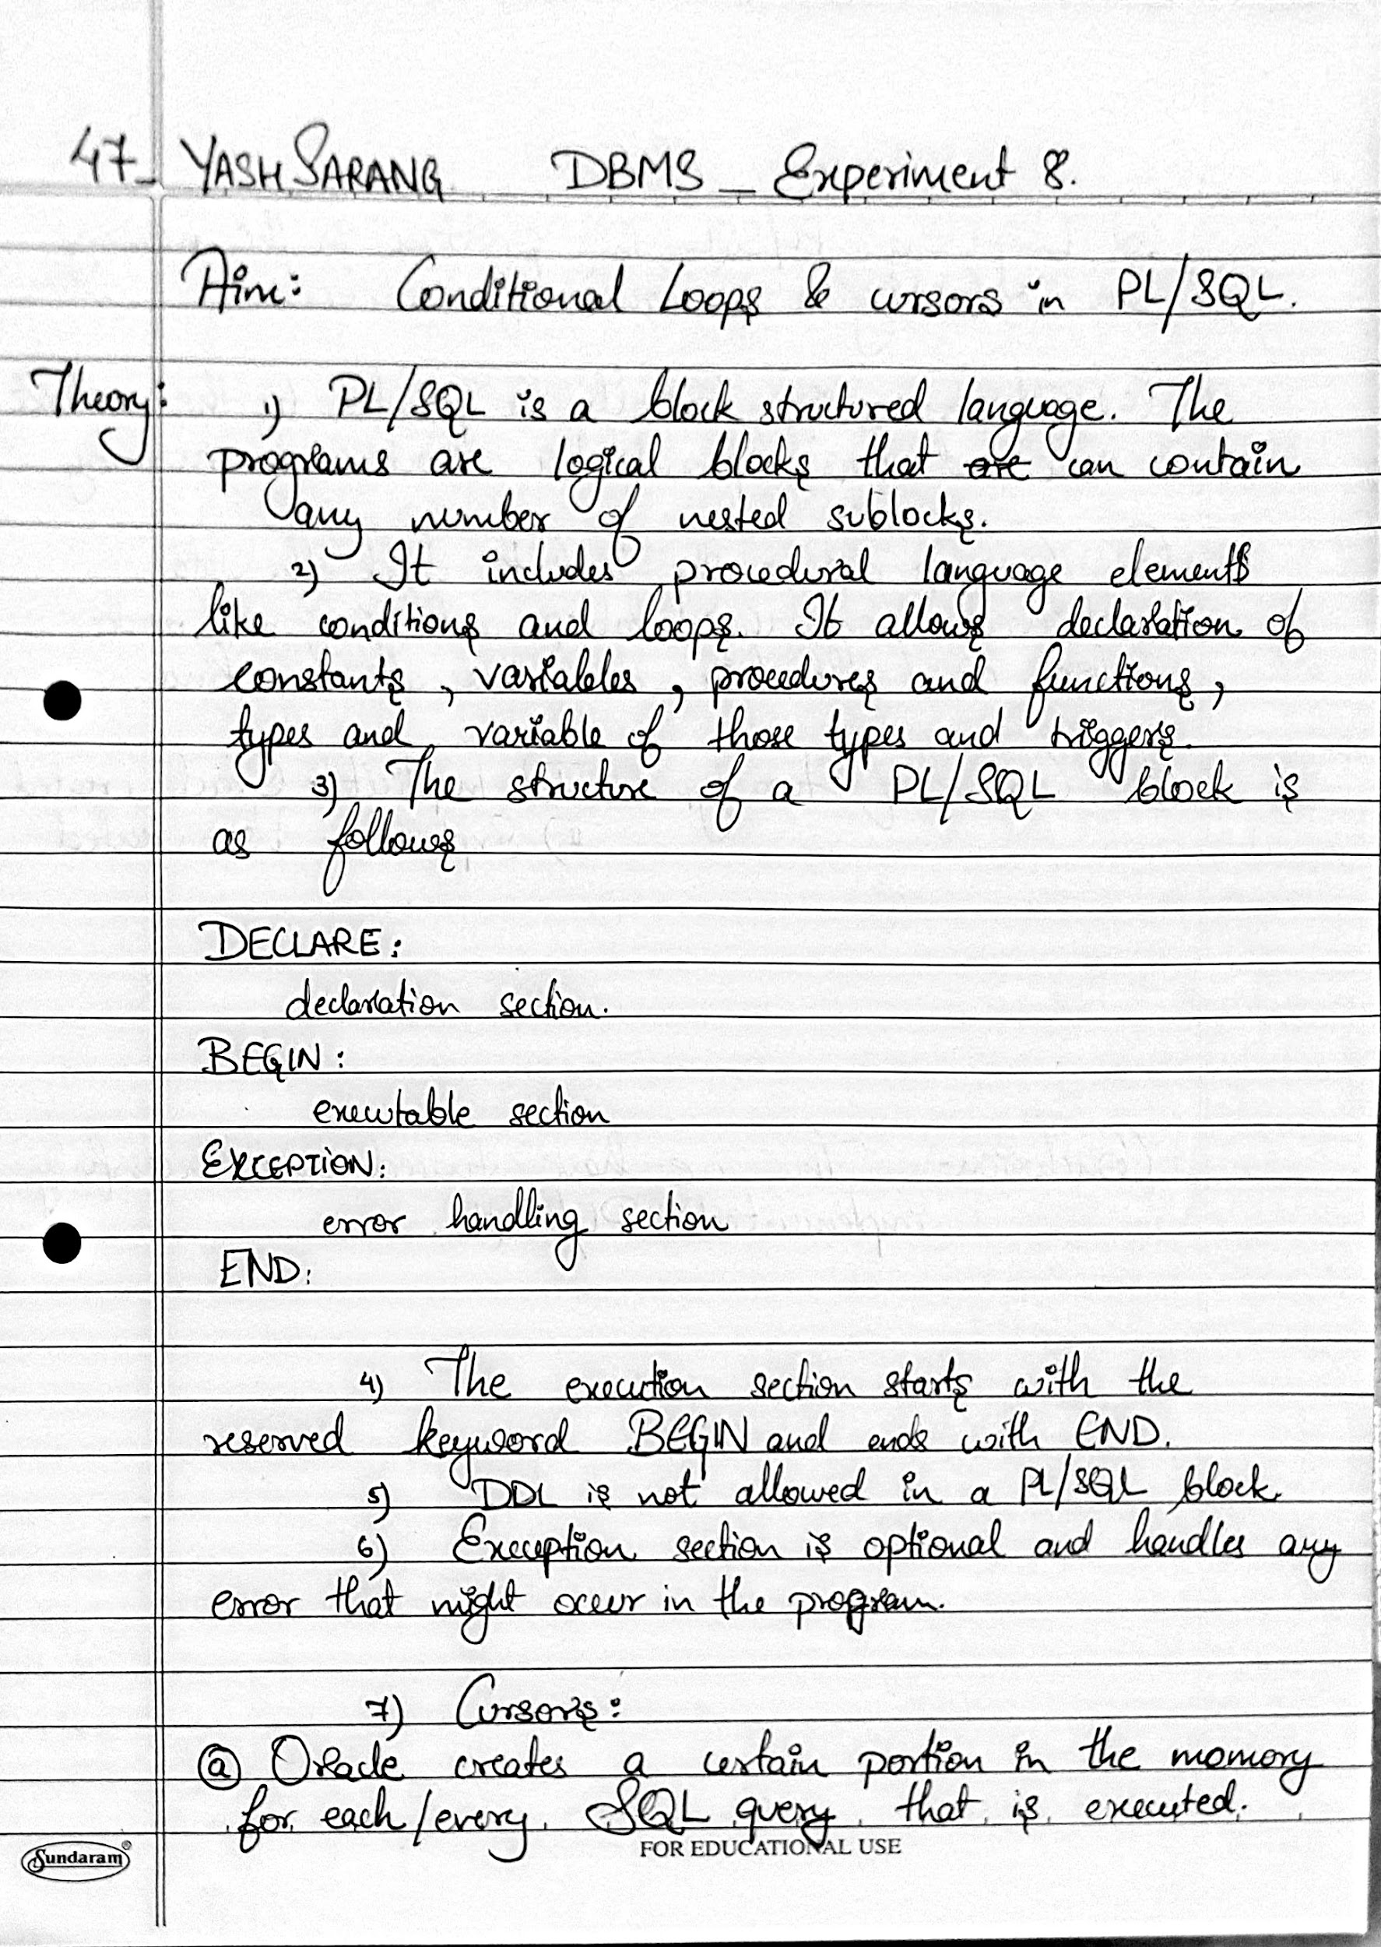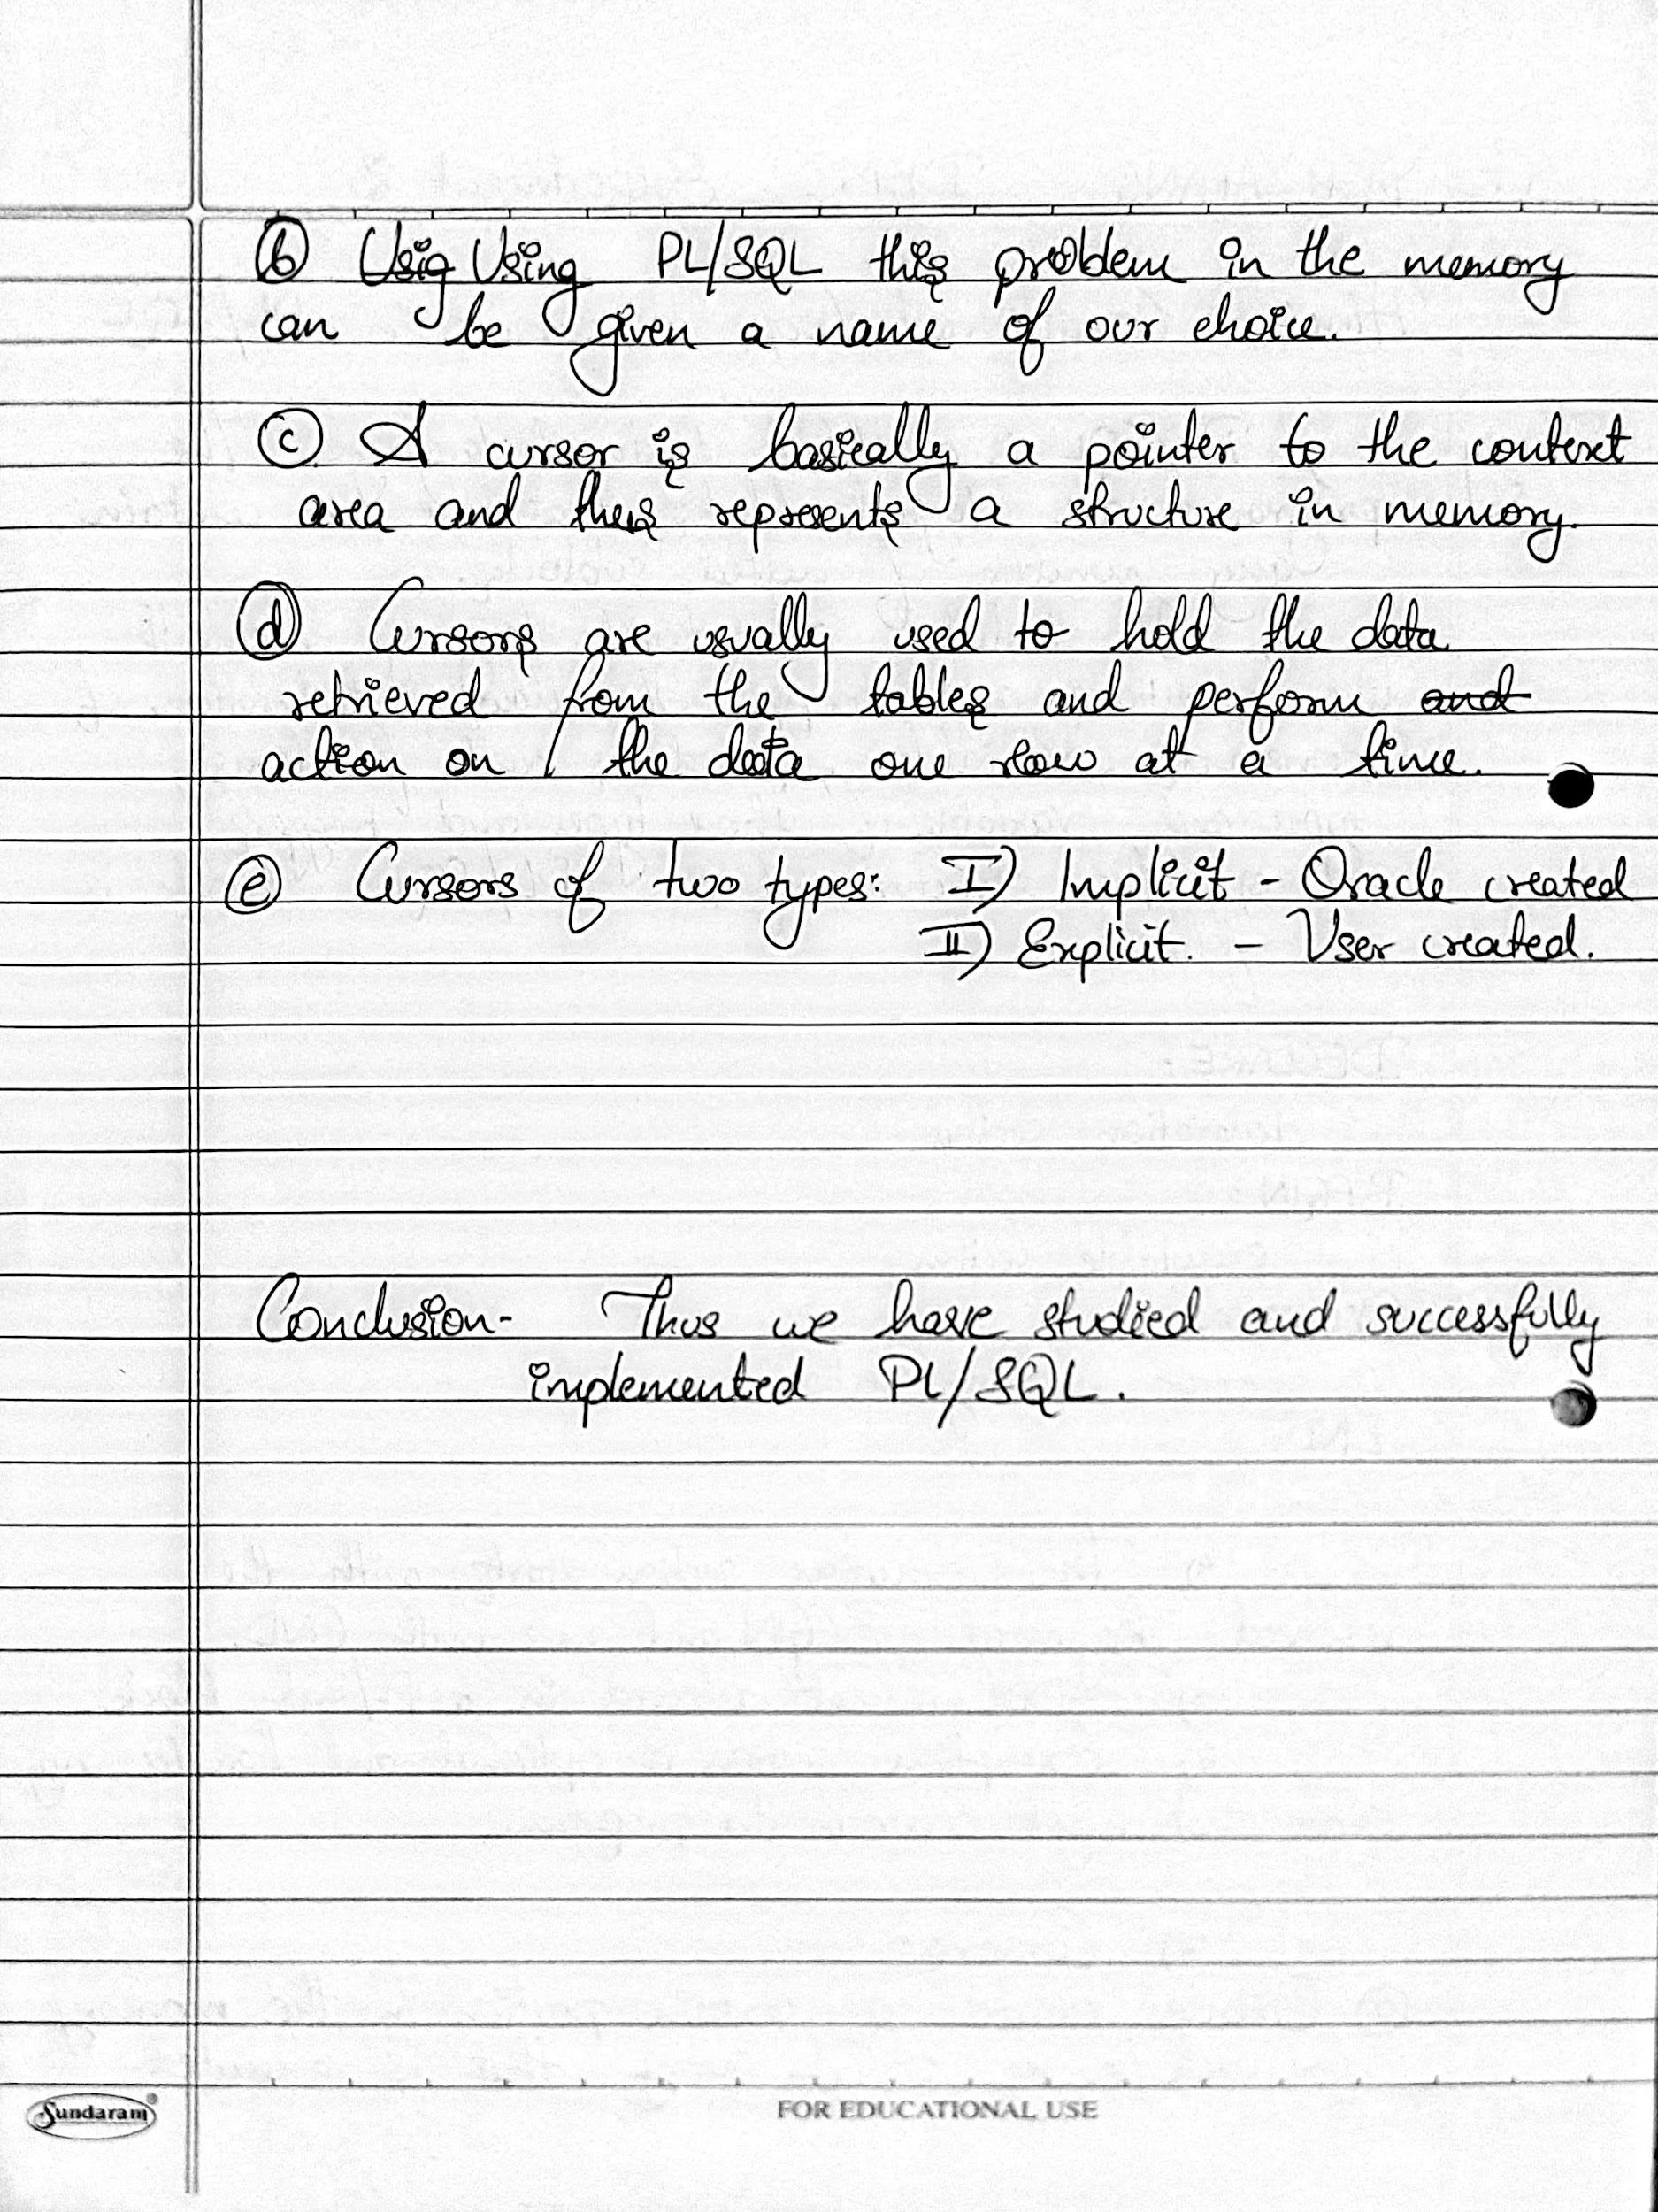

**SQL QUERIES:**

**1. To give raises to all employees earning a salary less than 1500.**

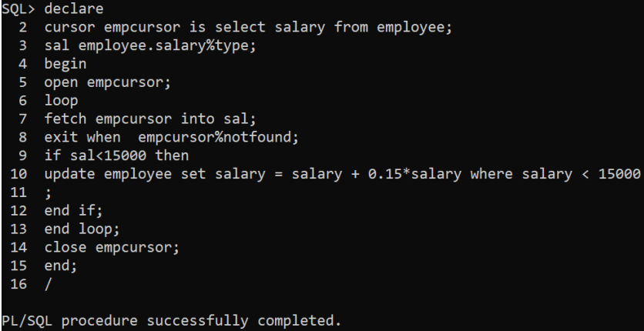

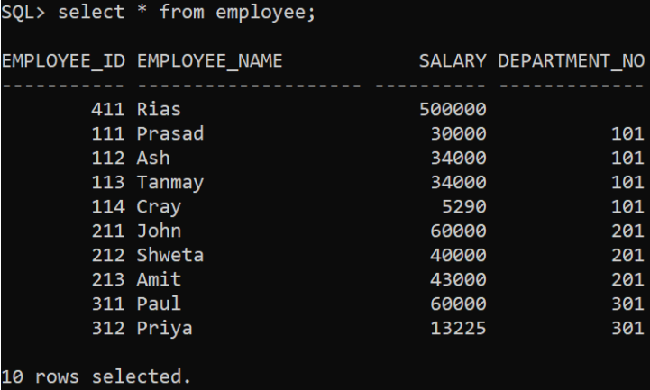

**2. To set job of all clerks with salary greater than 1300 as “Senior Clerk”**



